Program Budgeting: Say “YES” to pie charts and “NO” to line items
Posted in Annual Budget Drive, Fundraising, Operational/Organizational Aspects, Stewardship Education on November 16th, 2009 by Wayne Clark – 15 Comments
Are you frustrated that your fixed costs and employee salary packages represent the bulk of your line item budget? Can you imagine your annual budget development process devoid of drama, line-by-line contentious arguments, and anxiety about which line items to decrease or eliminate? Because this scenario is so prevalent and fraught with negativity, I want to share this information with you.
When congregants are asked to make a financial commitment to the annual operating budget, most want to know where their money is going and how it will make a difference. At the same time, they don’t want to be overwhelmed with too much financial detail. The best approach is to develop a program budget and to communicate it through pie charts.
Program budgeting is a method designed to clarify and simplify the operating budget. A typical congregational program budget divides annual income into four or five sources and annual expenses into four or five broad categories. Pie charts show the proportion of income from each source and the proportion of expenses in each category.
A program budget does not replace a line-item budget. It serves as an introduction to the proposed budget. The program budget proposal is shared with congregants when they are asked to make their financial commitment. The pie charts make it easy to see where financial resources come from and how the congregation chooses to allocate them, including the relative significance of various programs and ministries. These priorities may be altered if the congregation chooses. After the annual budget drive, the pie charts are converted into a line-item budget and presented to the congregation for adoption.
In a program budget, sources of income typically include annual financial commitments, rental income, program fees, and donations. A healthy annual income distribution requires that at least 80 percent of income is derived from annual financial commitments.
A healthy congregation does not use money from the endowment fund to balance an annual operating budget. As explained in Chapter 8 of Beyond Fundraising: A Complete Guide to Congregational Stewardship, endowment fund income is typically designated for capital projects and “rainy day” surprises. Nor should the congregation rely on income from service auctions, church fairs, yard sales, and similar events. Such events offer wonderful opportunities to build community, they are not cost-effective ways to balance the operating budget. I do not suggest elinating such events, instead I’m suggested that you give these contributions to a local or global community ministry—a worthwhile project or cause focused beyondthe walls of the congregation. A sample program budget income pie chart is found below and on page 50 of Beyond Fundraising.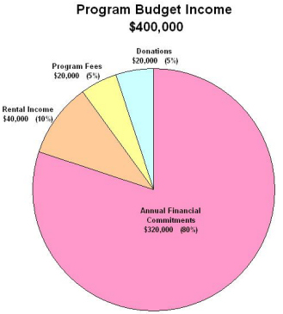
For expenses, consider the following categories: worship and music, lifespan religious education, community within, outreach (or global ministries), and denominational connection. While many Unitarian Universalist congregations allocate up to 10 percent of their operating budget to outreach, many nondenominational evangelical congregations devote 20 percent of their income—as well as many hours of sweat equity—to global ministry programs. A sample program budget expense pie chart is found below and on page 51 of Beyond Fundraising.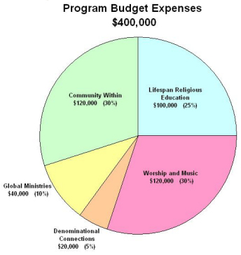
Many congregational finance leaders resist program budgeting, saying that congregants want the level of detail provided by a line-item budget. These leaders often believe that the more information people are given, the more money they will commit. On the contrary, line-item budgets confuse many people. At best, most congregants find them too tedious to explore in detail. Many fundraising consultants believe that there is no direct correlation between the amount of detailed financial information provided and the motivation to make a larger financial commitment. Remember: People give to other people, to programs, to ministries, and to worthy causes. People do not give to line item budgets.
So, at the start of your annual budget drive, use pie charts to depict projected income and expenses. Convert the pie chart to line items after you know how much operating income will be available from the financial commitments of your congregants.

